1. **SDLC OVERVIEW**

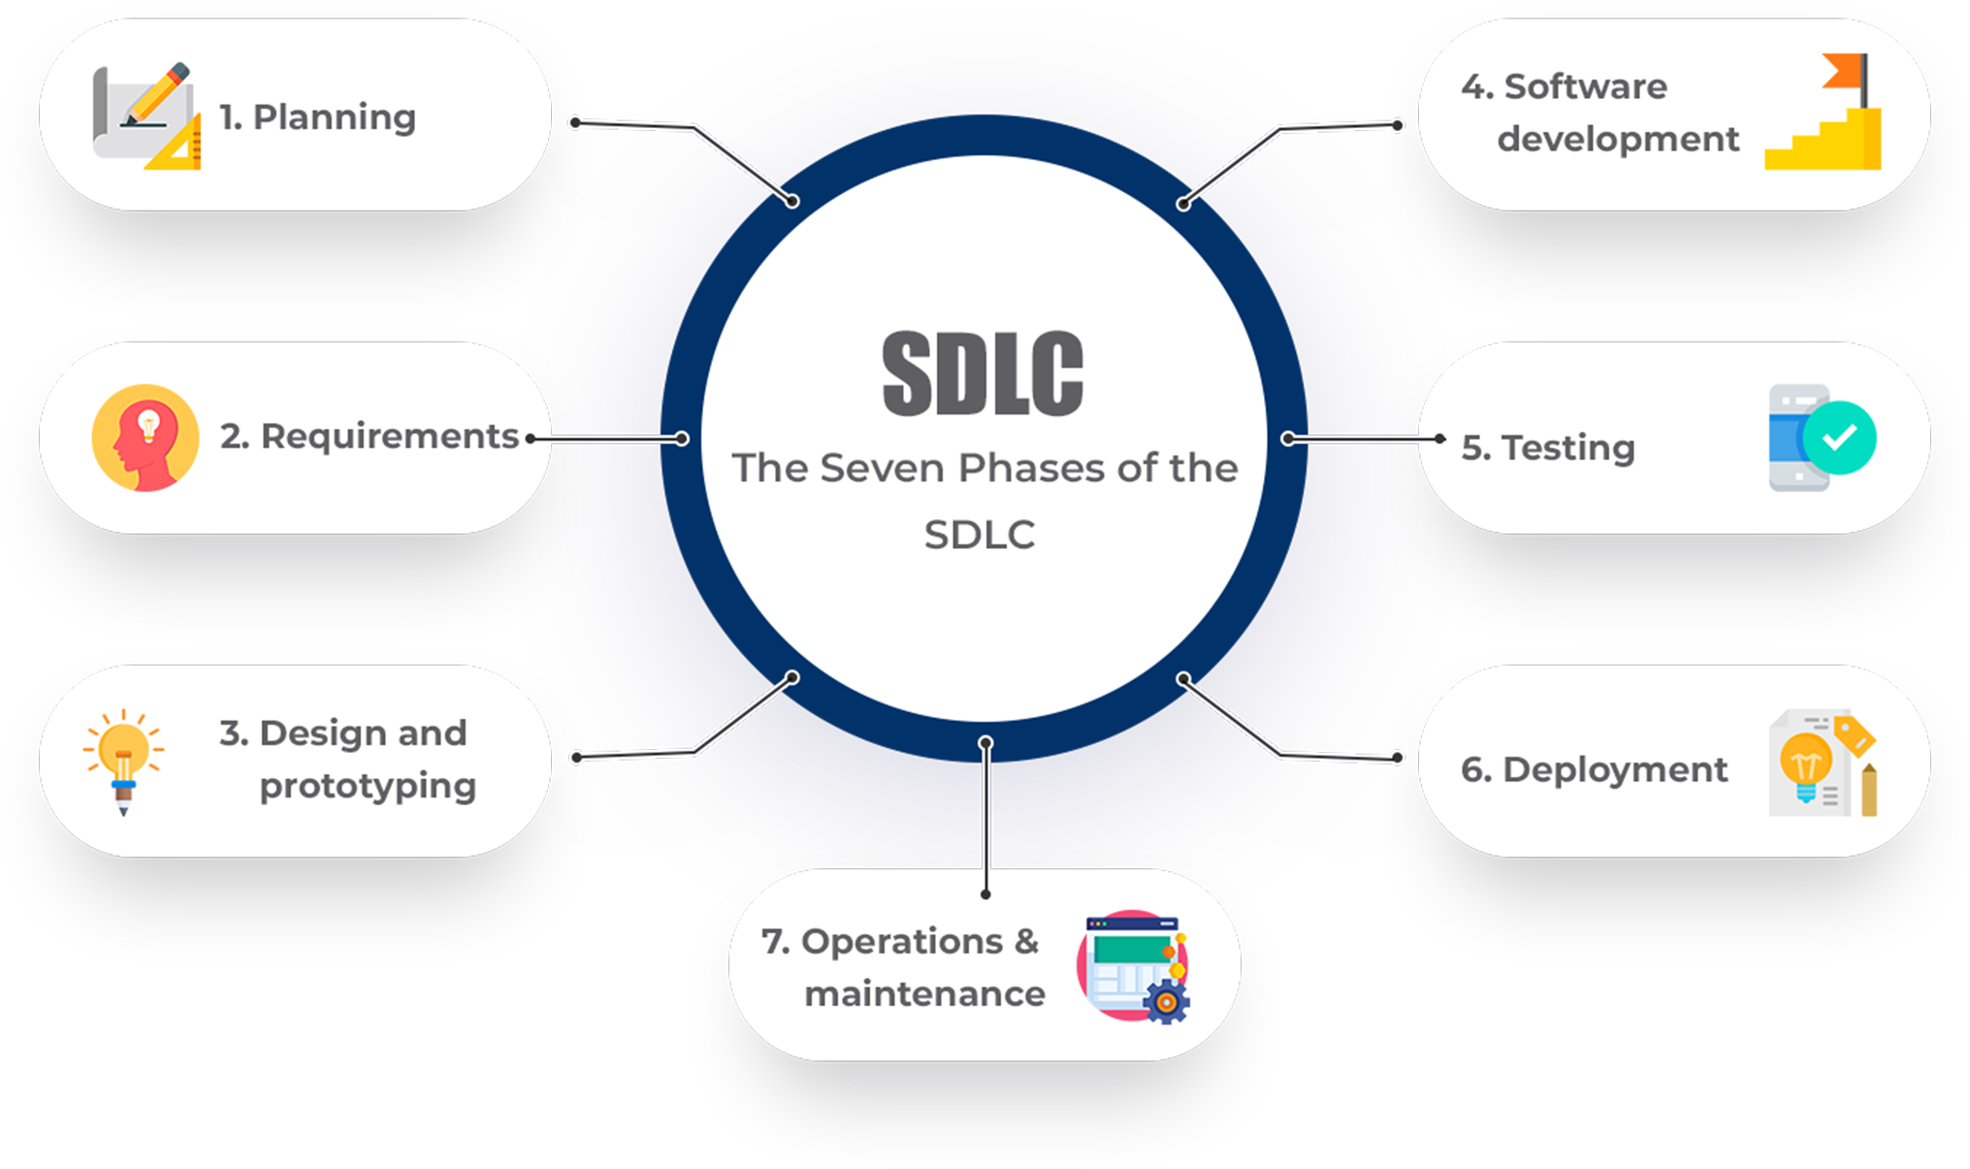

 

**2. REQUIREMENT GATHERING AND ANALYSIS**

* 1. **ORGANIZATION DETAILS:**

**1. Name of the Organization: -**

Asus

**2. Brief detail of the organization: -**

**ASUS** is an organization that deals with customers who are keen to buy gaming products with attractive RGB lights.

* 1. **MEETINGS:**

**I. Meeting with the CEO**

**1. Name of CEO**

- Mr. S.Y. HSU.

**2. CEO’s requirement in her words.**

- User’s Login, List of Customers, List of Products, Admin Login, etc.

**II. Meeting with the user**

1. **Name of the user.**

-Mr. Samson Hu.

1. **User requirement in her words.**

* A System is required to buy products and then the admin has a separate view of all the current orders and a category window to add and delete products

**2.3 Data which will be the input into the system….**

* Text
* Images

**2.4 Data which will be the output from the system….**

* Text
* Images

**2.5 Type of project….**

* Online

**2.6 Method for collecting data.**

* Meeting with Client
* Interview

**3. SYSTEM REQUIREMENT SPECIFICATIONS**

**3.1 Introduction:**

Asus Store is an online website that lets the end user rent properties such as houses, Apartments, and farmhouses for their vacation.

**3.1.1 Purpose:**

The purpose of creating this project is the end user can buy any product of ASUS Inc. for any kind of variant he/she wants.

* + 1. **Intended Audience and Reading Suggestions:**

The intended audience of this document is the potential end user. The document may also serve as a reference guide to the developers of the system.

* + 1. **Product Scope:**

The Application produced will be an online website. Everyone can buy products from the vast variety of ASUS Inc.

* 1. **Overall Description:**
     1. **Product Function:**

1. **Admin Module :**

* Login
* Manage Categories
* Manage Products
* Manage Orders

1. **User Module :**

* Register
* Login
* View Products
* Buy Products
* View Cart
* View Order Summary
  + 1. **User classes and characteristics:**

1. **User Classes :**

* Administrator
* Customer

1. **User Characteristics :**
2. Administrator:

Admin must be capable of managing Database & Materials.

1. Customer:

User should have a basic idea about electronic gadgets and their functionalities.

* + 1. **Operating Environment:**

This website will operate through the internet including browsing platforms like Chrome, Firefox, and also the operating system **Windows (7 or above).**

* + 1. **Design and Implementation constraints:**
* GUI is only in English.
* An Internet connection is required.
* Users should have basic knowledge of website operations.
  + 1. **Assumptions and dependencies:**
* Administrator is created in the system already.
* The database will be managed by the admin only.
* Roles and tasks are predefined.

**3.3 External Interface Requirement:**

**3.3.1 User Interface:**

In case the user is not registered. He/She can enter the details and create an account. Once the account is created user can ‘login’. If the username or password is incorrect then an error message appears.

**3.3.2 Software Interface:**

* Operating System – Windows, MacOS, Linux
* Front End – ASP.NET
* Back End – MySQL Server
* Software for Front End – Visual Studio
* Communication Interface – MySQL Activities
  1. **System Features:**
* To provide user login.
* To show Product list.
* To provide Product-wise Listings.

* 1. **Other Nonfunctional Requirements:**

**3.5.1 Performance requirement:**

* Overall System should be fast and error-free.
* It should have built-in error-checking and correction facilities.
* The system should be able to handle large amounts of data.
  + 1. **Security Requirement:**
* Administrator has more rights than user
  + 1. **Safety Requirement**:
* To prevent data loss in case of system failure, the request will be sent to the Admin.
  1. **Feasibility Study**

A feasibility study is a preliminary investigation of a proposed system to decide whether the system can run smoothly within the organization.

**3.6.1 Operational Feasibility: -**

Operational feasibility is the measure of how well a proposed system solves problems and takes advantage of the opportunities identified during scope definition and how it satisfies the requirements identified in the requirements analysis phase of system development

**3.6.2 Technical Feasibility: -**

Technical feasibility determines whether the work for the project can be done with the existing equipment, software technology, and available personnel.

Technical feasibility is concerned with specifying equipment and software that will satisfy the user's requirements.

**3.6.3 Economic Feasibility: -**

Economic feasibility determines whether there are sufficient benefits in creating to make the cost acceptable, or if the cost of the system is too high.

So this signifies cost-benefit analysis and savings on behalf of the cost-benefit analysis.

**3.6.4 Schedule Feasibility: -**

How long will it take to get the technical expertise?

We may have the technology, but that doesn’t mean we have the skills required to properly apply that technology.

1. **SYSTEM ANALYSIS AND MODELING**
   1. **Use case Diagram:**

**1) Admin Side**

Login

Manage

Categories

Manage

Products

Manage

Orders

View

Queries

**2) User Side**

Register

Login

View

Products

Buy

Products

View

Cart

* 1. **Normalization & E-R Diagram:**

Normalization is the process of organizing the [columns](https://en.wikipedia.org/wiki/Column_(database)) (attributes) and [tables](https://en.wikipedia.org/wiki/Table_(database)) (relations) of a [relational database](https://en.wikipedia.org/wiki/Relational_database) to reduce [data redundancy](https://en.wikipedia.org/wiki/Data_redundancy) and improve data integrity.

* **Un – Normalized Data:**

|  |  |  |  |  |  |
| --- | --- | --- | --- | --- | --- |
| User_id | Username | Cat_id | MRP | password | image |
| 8 | Rahul | 2 | 42500 | Rahul@123 | rog-azoth.jpg |
| 9 | Preet | 1 | 21000 | Preet@123 | rog-ally2.png |

* **Normalized Form:**

1. **1st Normal Form:**
2. **Table Name:** admin_users

**Primary Key:** id (Auto Increment)

|  |  |  |
| --- | --- | --- |
| Id  *(AI) | username | password |
| 1 | admin | admin@123 |

1. **Table Name:** users

**Primary Key:** id (Auto Increment)

|  |  |  |  |  |  |
| --- | --- | --- | --- | --- | --- |
| id  *(AI) | name | email | phno | username | password |
| 8 | Rahul | rahul@gmail.com | 9409479818 | Rahul | Rahul@123 |
| 9 | Preet | preet@gmail.com | 6351400634 | Preet | Preet@123 |

1. **2nd Normal Form:**
2. **Table Name:** category

**Primary Key:** id (Auto Increment)

|  |  |
| --- | --- |
| id  *(AI) | Cat_name |
| 1 | laptop |
| 2 | Keyboard |
| 3 | Router |

1. **Table Name:** products

**Primary Key:** id (Auto Increment)

**Foreign Key:** cat_id

|  |  |  |  |  |  |  |
| --- | --- | --- | --- | --- | --- | --- |
| Id  *(AI) | image | Name | Mrp | Slp | Description | Cat_id  (FK) |
| 2 | rog-azoth.jpg | ROG Azoth | 42999 | 35999 | keyboard | 2 |
| 5 | rog-ally2.png | ROG Ally | 83990 | 69990 | console | 8 |

1. **Table Name:** cart

**Primary Key:** id (Auto Increment)

**Foreign Key:** u_id, p_id

|  |  |  |  |  |  |  |  |
| --- | --- | --- | --- | --- | --- | --- | --- |
| Id  *(AI) | u_id  (FK) | p_id  (FK) | image | name | qty | price | total_price |
| 3 | 9 | 17 | asus-z790.jpg | ASUS ROG Strix | 1 | 52795 | 52795 |
| 4 | 8 | 11 | asus-graphics-card-1.jpg | ASUS Phoenix | 3 | 8700 | 26100 |

1. **Table Name:** contact

**Primary Key:** id (Auto Increment)

|  |  |  |  |
| --- | --- | --- | --- |
| Id  *(AI) | name | email | Message |
| 8 | Rahul | rahul@gmail.com | Hello |
| 9 | Preet | preet@gmail.com | Sample message |

1. **Table Name:** order_details

**Primary Key:** id (Auto Increment)

**Foreign Key:** order_id, u_id, p_id

|  |  |  |  |  |  |  |  |
| --- | --- | --- | --- | --- | --- | --- | --- |
| Id  *(AI) | Order_id  (FK) | u_id  (FK) | p_id  (FK) | image | name | price | qty |
| 1 | 1 | 8 | 6 | rog-7ultimate-phone.jpg | ASUS ROG Phone 7 Ultimate | 99999 | 1 |

* **E-R Diagram:**

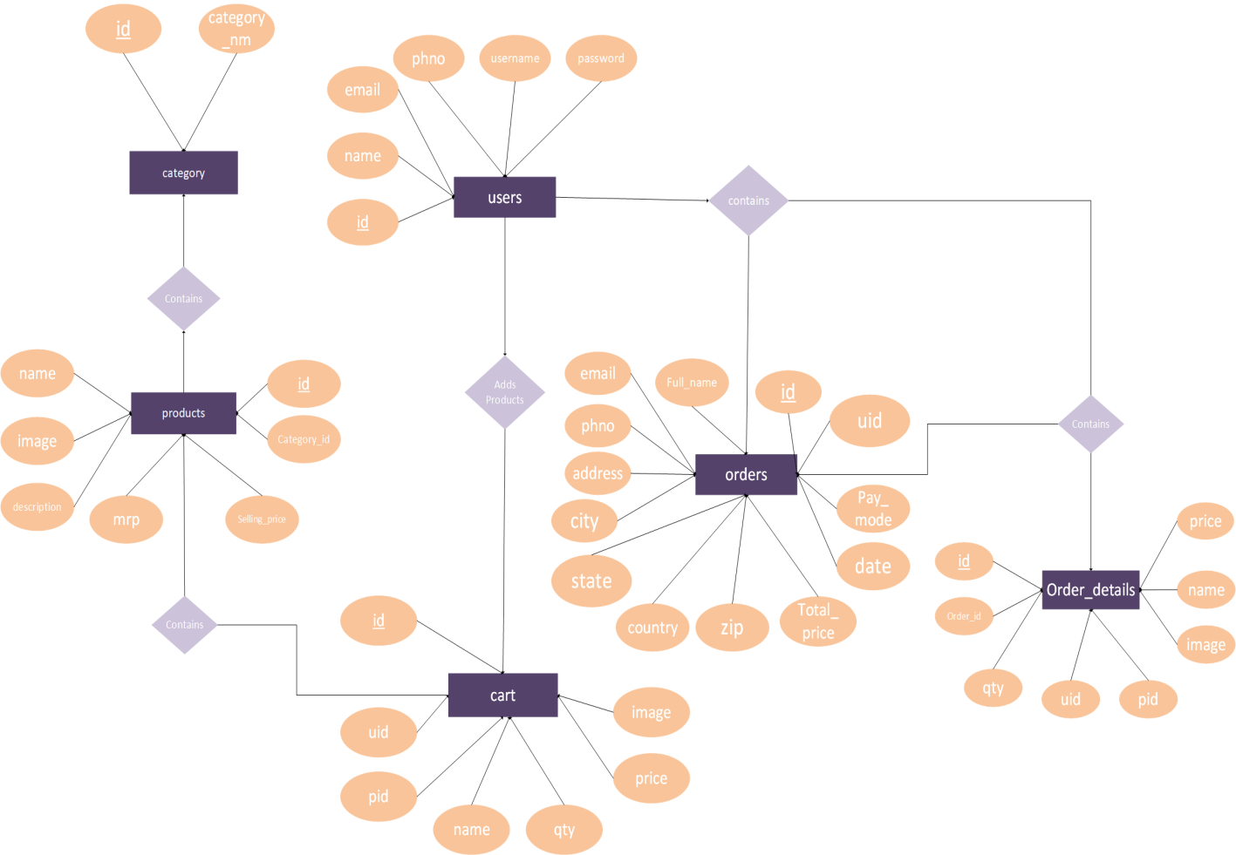

* 1. **Data Dictionary**

1. **users:**

|  |  |  |  |  |  |
| --- | --- | --- | --- | --- | --- |
| SRNO. | COLUMN NAME | DATATYPE | NULL | LINKS TO | COMMENTS |
| 1 | Id | Int(11) | NO |  | Primary Key, Auto Increment |
| 2 | Name | Varchar(50) | NO |  |  |
| 3 | Phno | BigInt(50) | NO |  |  |
| 4 | Email | Varchar(50) | NO |  |  |
| 5 | Username | Varchar(50) | NO |  |  |
| 6 | Password | Varchar(50) | NO |  |  |

1. **admin_users:**

|  |  |  |  |  |  |
| --- | --- | --- | --- | --- | --- |
| SRNO. | COLUMN NAME | DATATYPE | NULL | LINKS TO | COMMENTS |
| 1 | Id | Int(11) | NO |  | Primary Key, Auto Increment |
| 2 | Username | Varchar(50) | No |  |  |
| 3 | Password | Varchar(50) | No |  |  |

1. **category:**

|  |  |  |  |  |  |
| --- | --- | --- | --- | --- | --- |
| SRNO. | COLUMN NAME | DATATYPE | NULL | LINKS TO | COMMENTS |
| 1 | Id | Int(11) | NO |  | Primary Key, Auto Increment |
| 2 | Cat_name | Varchar(50) | NO |  |  |

1. **product:**

|  |  |  |  |  |  |
| --- | --- | --- | --- | --- | --- |
| SRNO. | COLUMN NAME | DATATYPE | NULL | LINKS TO | COMMENTS |
| 1 | Id | Int(11) | NO |  | Primary Key, Auto Increment |
| 2 | cat_id | Int(11) | NO |  |  |
| 3 | Image | Varchar(50) | NO | category🡪 catid | Foreign Key |
| 4 | Name | Varchar(50) | NO |  | Foreign Key |
| 5 | Mrp | Float | NO |  | Foreign Key |
| 6 | Slp | Float | NO |  |  |
| 7 | Description | Varchar(Max) | NO |  |  |

1. **contact:**

|  |  |  |  |  |  |
| --- | --- | --- | --- | --- | --- |
| SRNO. | COLUMN NAME | DATATYPE | NULL | LINKS TO | COMMENTS |
| 1 | Id | Int(11) | NO |  | Primary Key, Auto Increment |
| 2 | Name | Varchar(50) | NO |  |  |
| 3 | Email | Varchar(50) | NO |  |  |
| 4 | Message | Varchar(Max) | NO |  |  |

1. **cart:**

|  |  |  |  |  |  |
| --- | --- | --- | --- | --- | --- |
| SRNO. | COLUMN NAME | DATATYPE | NULL | LINKS TO | COMMENTS |
| 1 | Id | Int(11) | NO |  | Primary Key, Auto Increment |
| 2 | Uid | Int(11) | NO | Users🡪userid |  |
| 3 | Pid | Int(11) | NO | product🡪  productid |  |
| 4 | Iamge | Varchar(50) | NO |  |  |
| 5 | Name | Varchar(50) | NO |  |  |
| 6 | Quantity | Int(11) | NO |  |  |
| 7 | Price | Float | NO |  |  |
| 8 | Total_price | Float | NO |  |  |

1. **orders:**

|  |  |  |  |  |  |
| --- | --- | --- | --- | --- | --- |
| SR NO. | COLUMN NAME | DATATYPE | NULL | LINKS TO | COMMENTS |
| 1 | Id | Int(11) | NO |  | Primary Key,  Auto Increment |
| 2 | Uid | Int(11) | NO | Users🡪  userid | Foreign Key |
| 3 | Name | Varchar(50) | NO |  |  |
| 4 | Email | Varchar(50) | NO |  |  |
| 5 | Phno | BigInt | NO |  |  |
| 6 | Address | Varchar(Max) | NO |  |  |
| 7 | City | Varchar(50) | NO |  |  |
| 8 | Country | Varchar(50) | NO |  |  |
| 9 | State | Varchar(50) | NO |  |  |
| 10 | Zip | BigInt | NO |  |  |
| 11 | Total_price | Float | NO |  |  |
| 12 | Date | Varchar(50) | NO |  |  |
| 13 | Pay_mode | Varchar(50) | NO |  |  |

1. **order_details:**

|  |  |  |  |  |  |
| --- | --- | --- | --- | --- | --- |
| SR NO. | COLUMN NAME | DATATYPE | NULL | LINKS TO | COMMENTS |
| 1 | Id | Int(11) | NO |  | Primary Key,  Auto Increment |
| 2 | Order_id | Int(11) | NO | Orders🡪  orderid | Foreign Key |
| 3 | Uid | Int(11) | NO | Users🡪  Userid | Foreign Key |
| 4 | Pid | Int(11) | NO | Product🡪  productid | Foreign Key |
| 5 | Image | Varchar(100) | NO |  |  |
| 6 | Name | Varchar(100) | NO |  |  |
| 7 | Price | Float | NO |  |  |
| 8 | Quantity | Int(2) | NO |  |  |

**4.3Functional and behavior modeling**

**4.3.1 Context Diagram (0-level Diagram)**

**­**

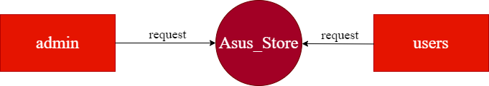

**4.3.2 First Level Diagram (1-level Diagram)**

* **USER**

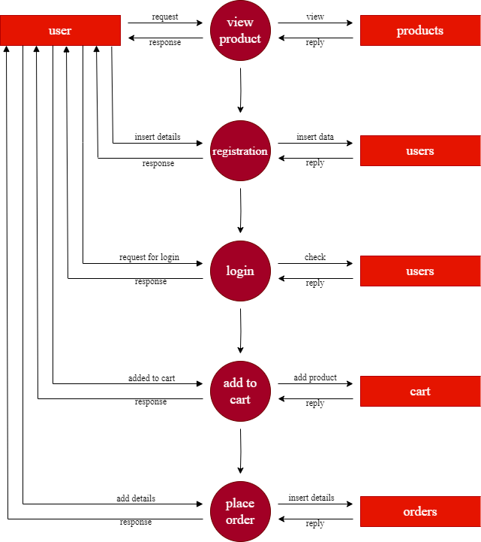

* **ADMIN**

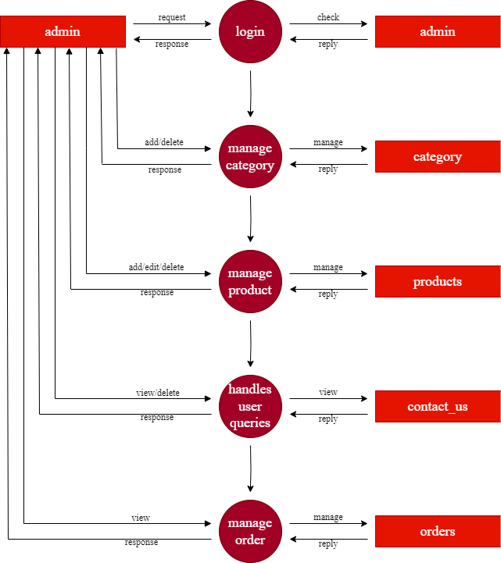

**4.4 Gantt Chart**

* Expected Time.
* Actual Time.

|  |  |  |  |  |  |  |
| --- | --- | --- | --- | --- | --- | --- |
| No. | Task | October | November | December | January | February |
| 1 | Requirement Gathering And SRS |  | | | |  |
| 2 | System Analysis |  | | | |  |
| 3 | System Design |  | | | |  |
| 4 | System Development |  | | | |  |
| 5 | System Testing |  | | | |  |
| 6 | Deployment |  | | | |  |

1. **TEST CASE**

|  |  |  |  |  |  |
| --- | --- | --- | --- | --- | --- |
| Login Module | | | | | |
| TEST CASE No. 1 | | | TEST CASE DESIGN DATE :  5/Jan /2024 | | |
| TEST TITLE: Login Module Test | | | TEST CASE EXECUTION DATE: 5/Jan/2024 | | |
| DESCRIPTION: In this test case Login module would be tested | | | | | |
| PRECONDITION: Login Activity must be working | | | | | |
| STEP No. | TEST STEP | TEST DATA | EXPECTED RESULT | ACTUAL RESULT | STATUS |
| 1 | Navigate to the Login Page | Login Activity | Login Activity is visible | Same As Expected | PASS |
| 2 | Enter Email | admin@gmail | Email is accepted | Invalid Email | FAIL |
| 3 | Enter Password­­­­­ | admin123 | Password is accepted | Same As Expected | PASS |
| 4 | Click Login Button | Button Click | Check Credentials | Same As Expected | PASS |

* Note: Email is not accepted in the above test case due to invalid format.

|  |  |  |  |  |  |
| --- | --- | --- | --- | --- | --- |
| Signup Module | | | | | |
| TEST CASE No. 2 | | | TEST CASE DESIGN DATE :  5/Jan/2024 | | |
| TEST TITLE: Signup Module Test | | | TEST CASE EXECUTION DATE: 5/Jan/2024 | | |
| DESCRIPTION: In this test case Signup Activity would be tested | | | | | |
| PRECONDITION: Signup Activity must be working | | | | | |
| STEP No. | TEST STEP | TEST DATA | EXPECTED RESULT | ACTUAL RESULT | STATUS |
| 1 | Navigate to Signup Activity | Signup Activity | Signup Activity is visible | Same As Expected | PASS |
| 2 | Enter All Fields | Data | Check Data Integrity | Same As Expected | PASS |
| 3 | Click Signup Button | Button Click | Signup done  With all Validation | Same As Expected | PASS |

1. **SCREENSHOTS**

* **User Side**

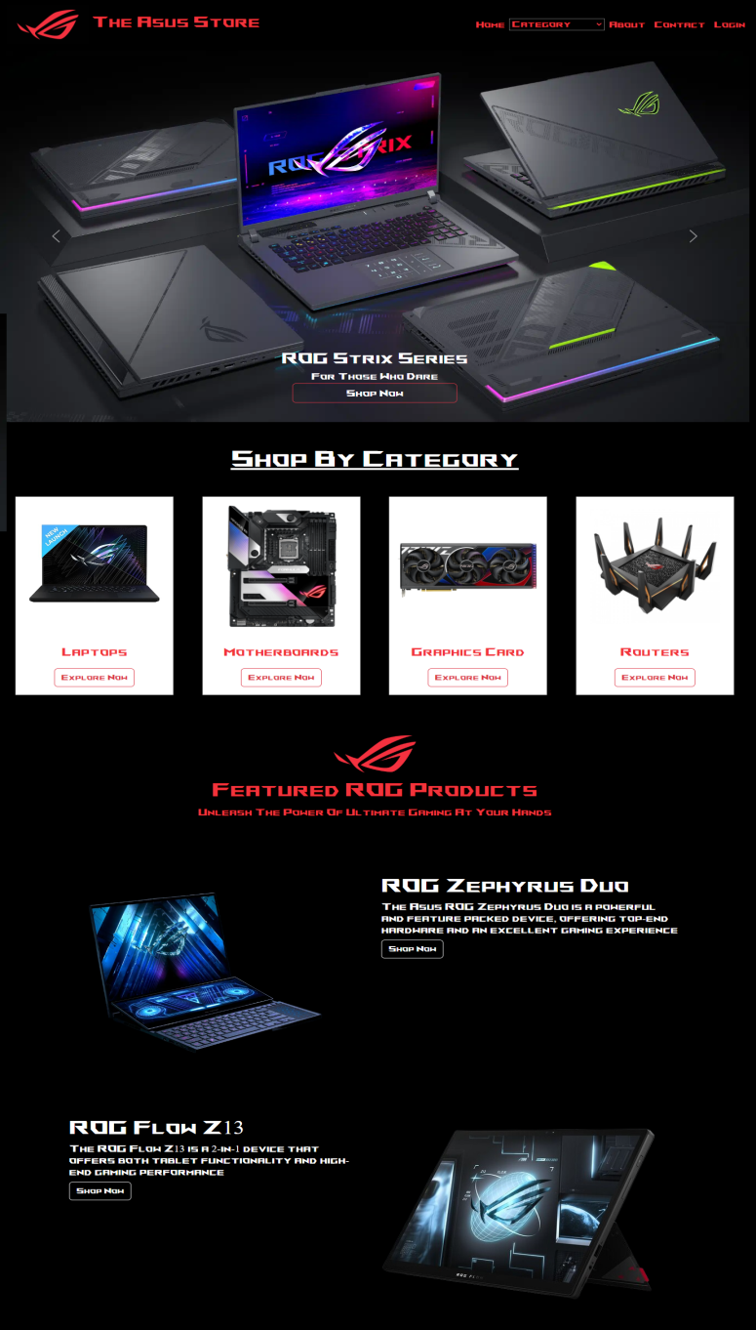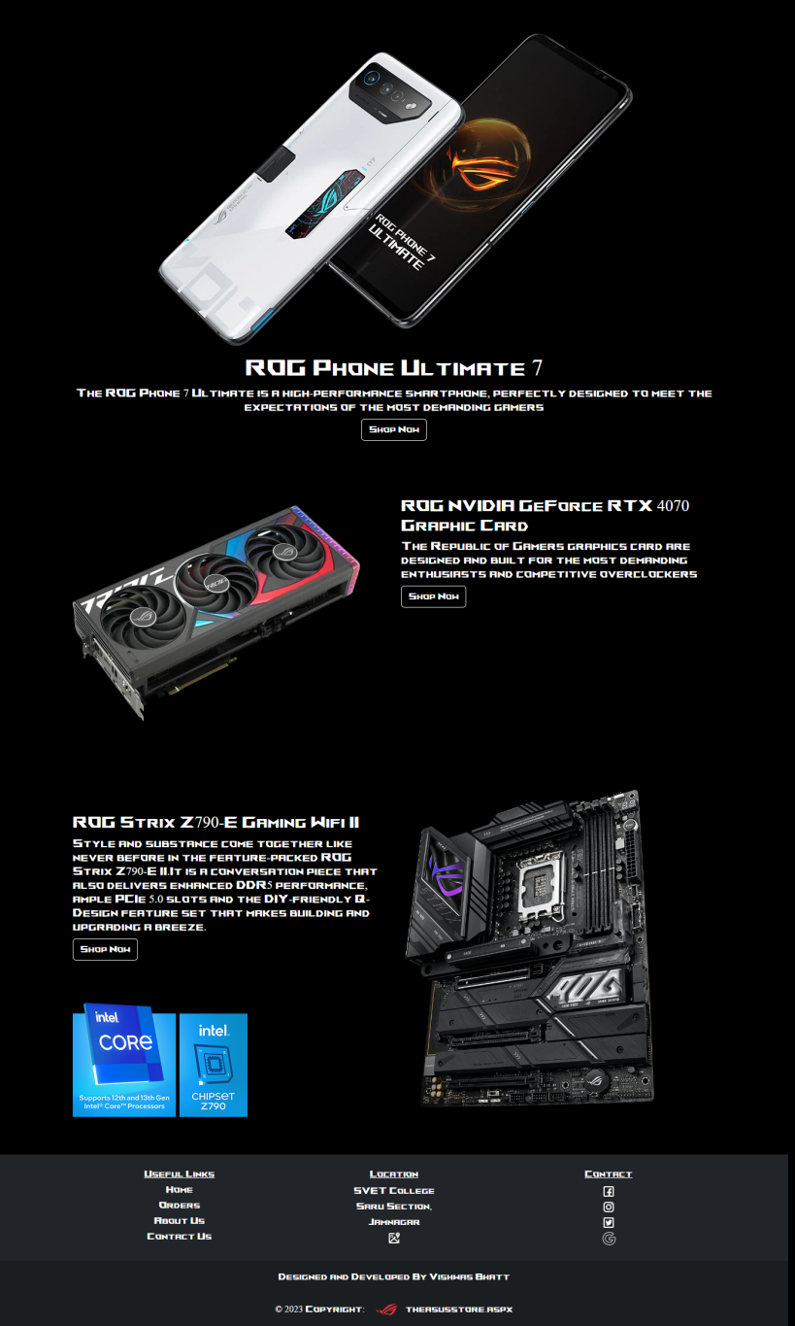

6.1This Page Displays Home Screen

* **Login Page**

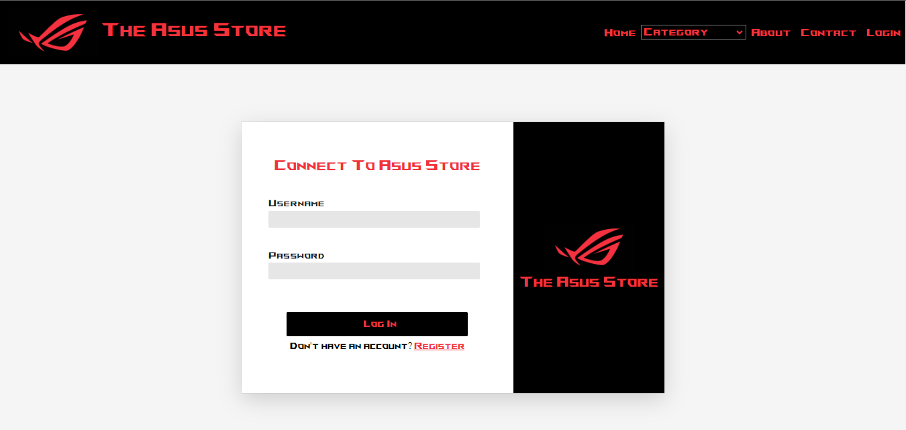

* 1. This Page Displays the Login Screen
* **Signup Activity**

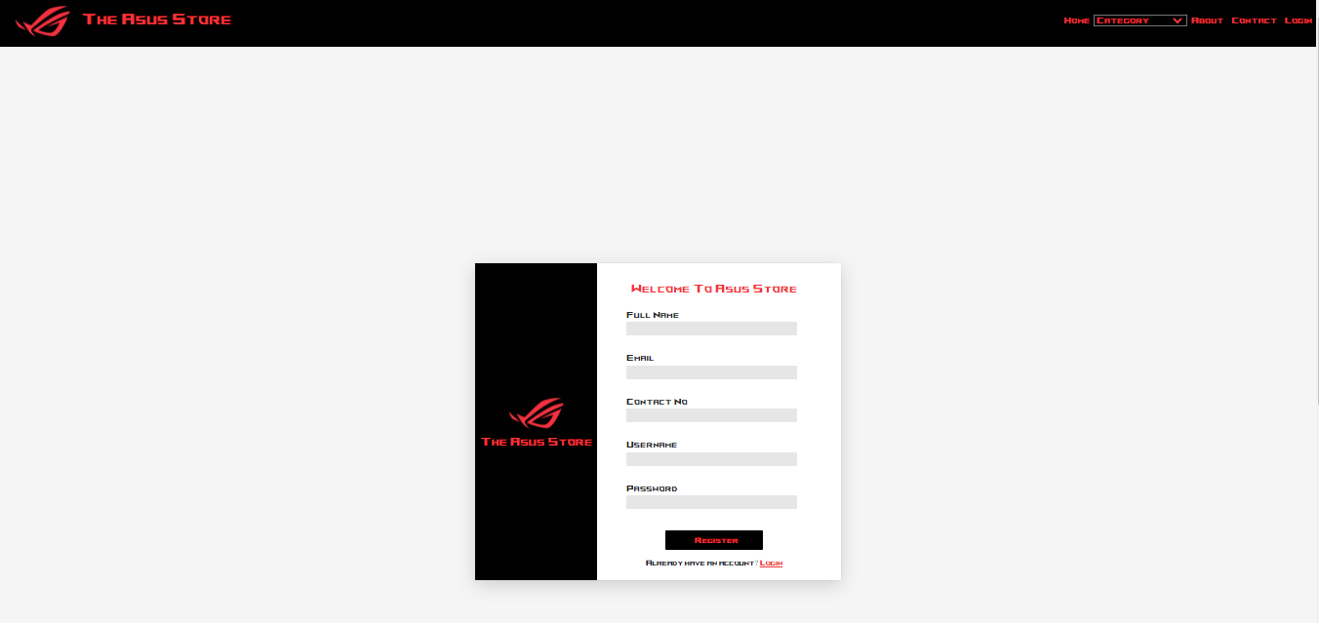

6.3 This Page Displays Signup Screen

* **Category Pages:-**

1. **Laptops**

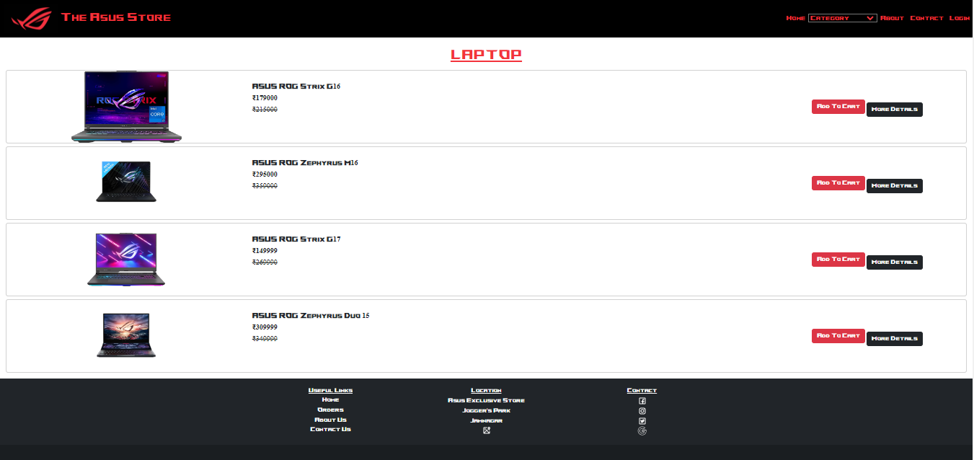

6.4 This Page Displays Various Categories of Laptops

1. **Keyboards**

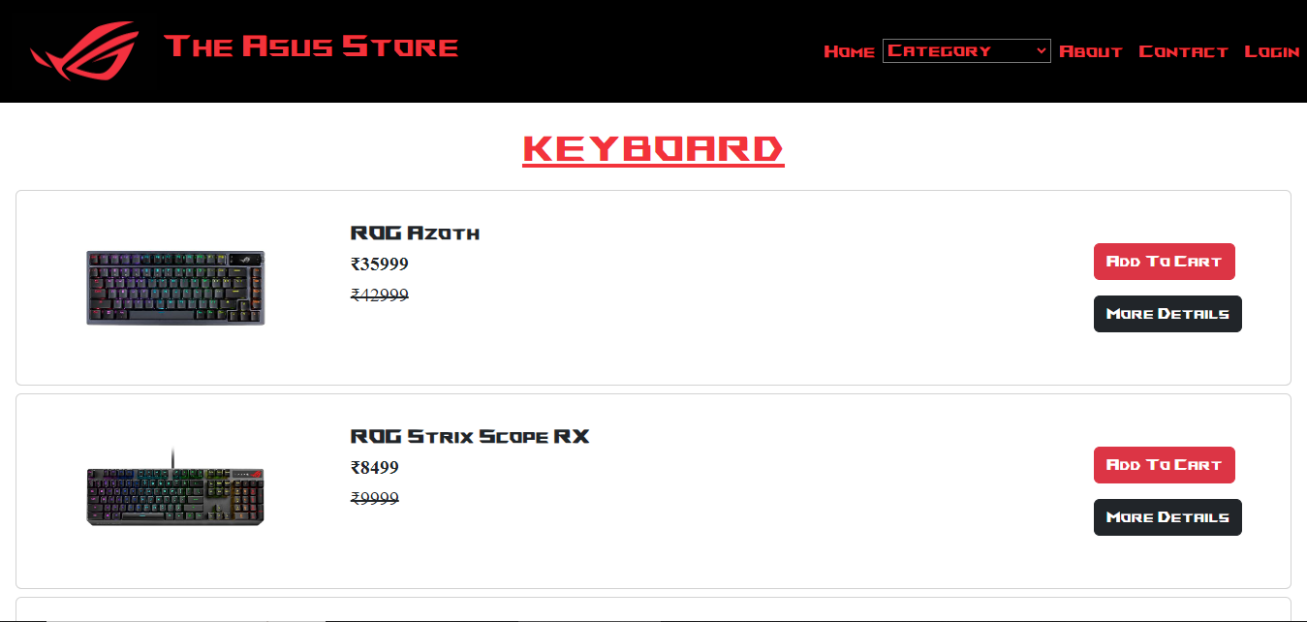

6.5 This Page Displays Various Categories of Keyboards

1. **Routers**

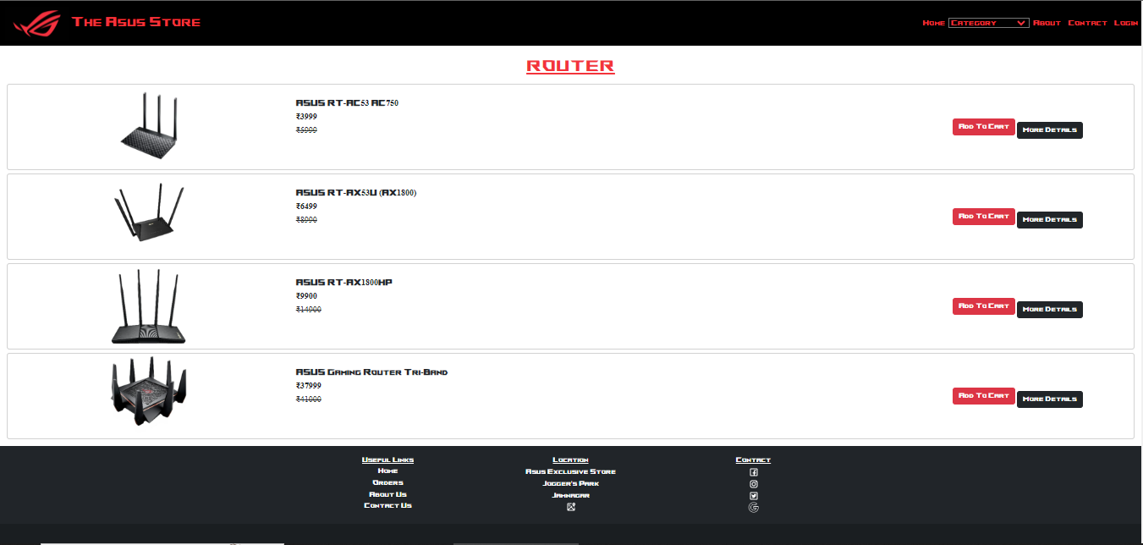

6.6 This Page Displays Various Categories of Routers

1. **Mother-Boards**

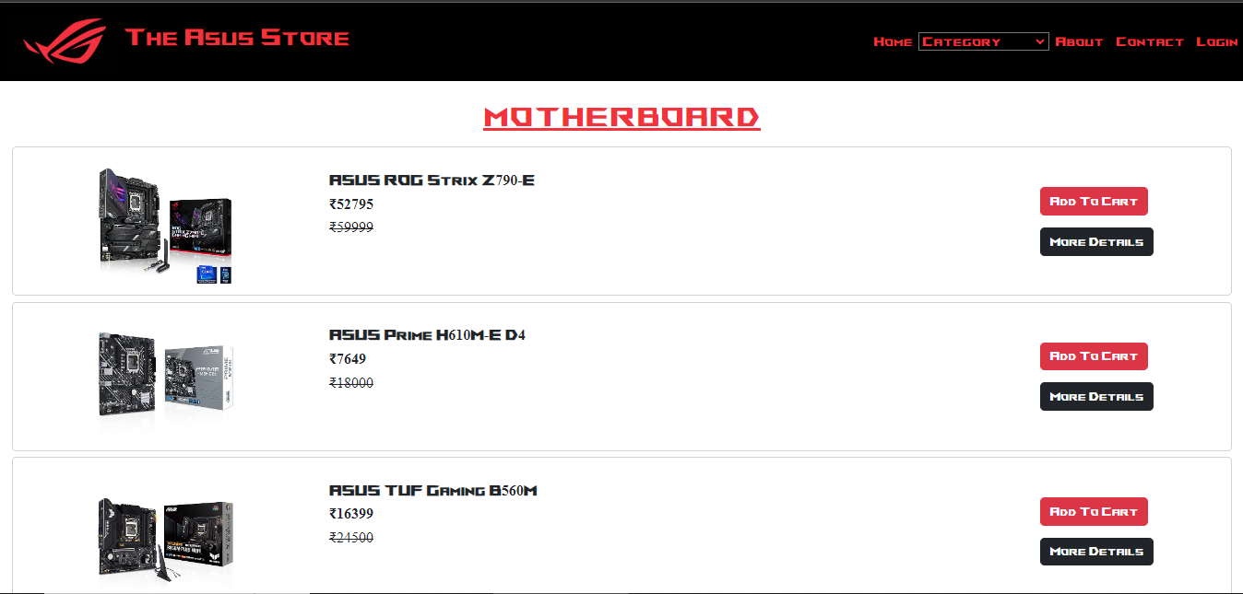

6.7 This Page Displays Various Categories of Mother-Boards

1. **Graphics Card**

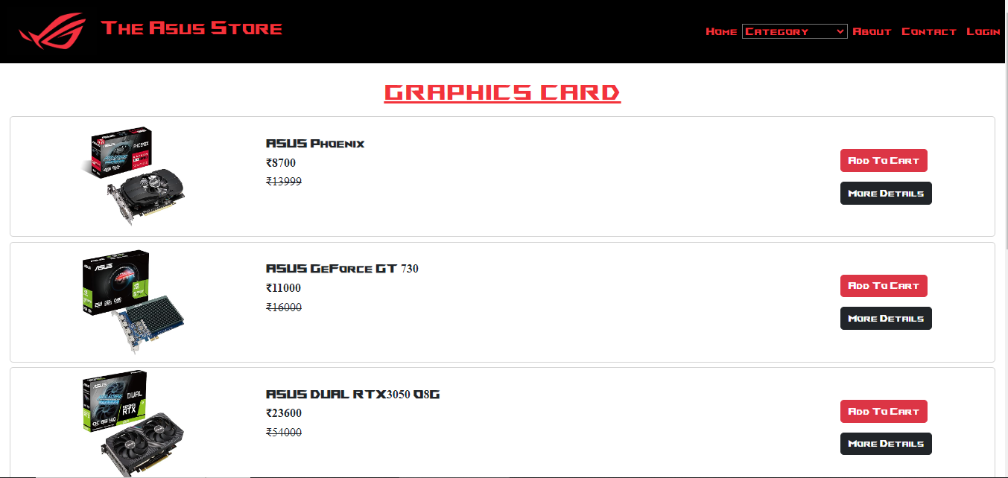

6.8 This Page Displays Various Categories of Graphics Cards

1. **Hand-Held**

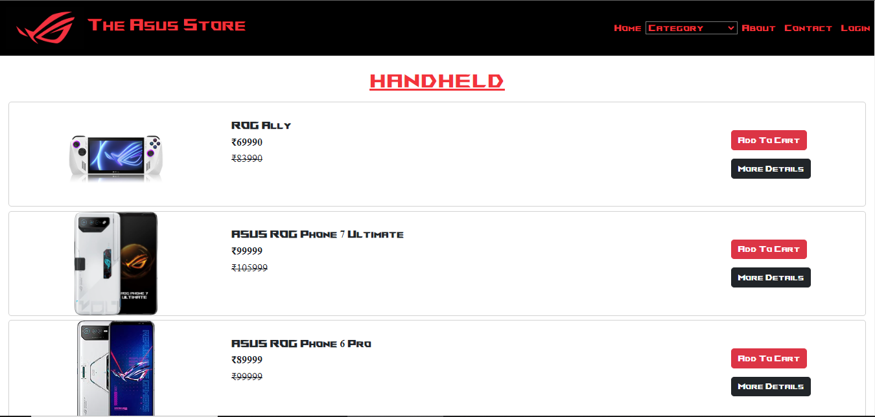

6.9 This Page Displays Various Categories of Hand-Holds

* **Cart Page:**

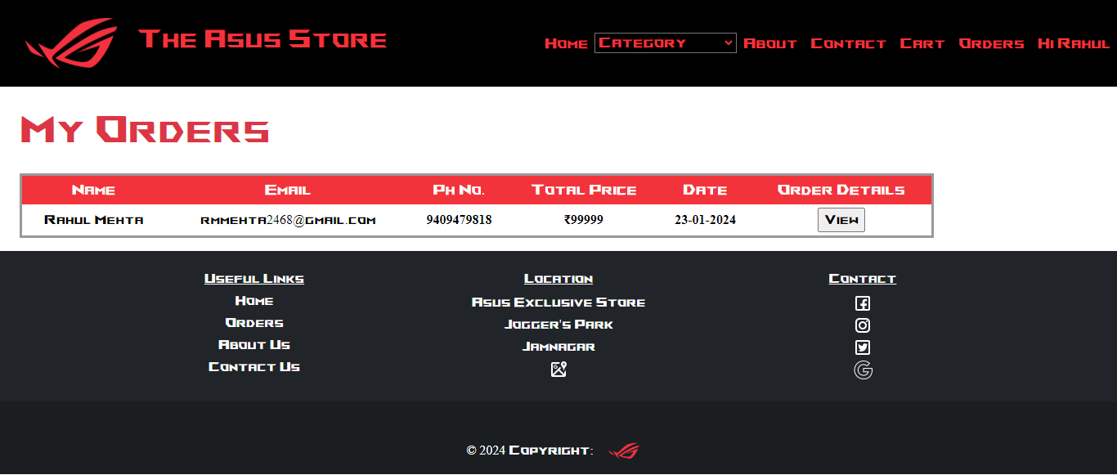

6.10 This Page shows the Products Added to the Cart

* **View Orders:**

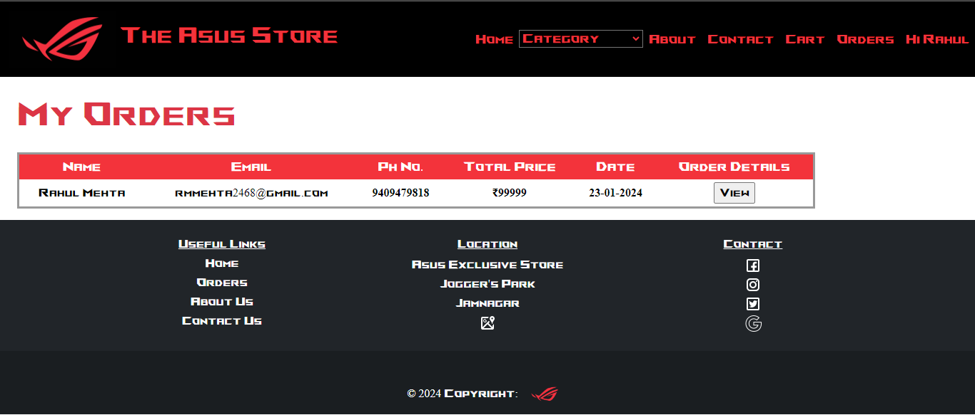

6.11 This Page shows the Orders Placed by the User

* **About Us Page:**

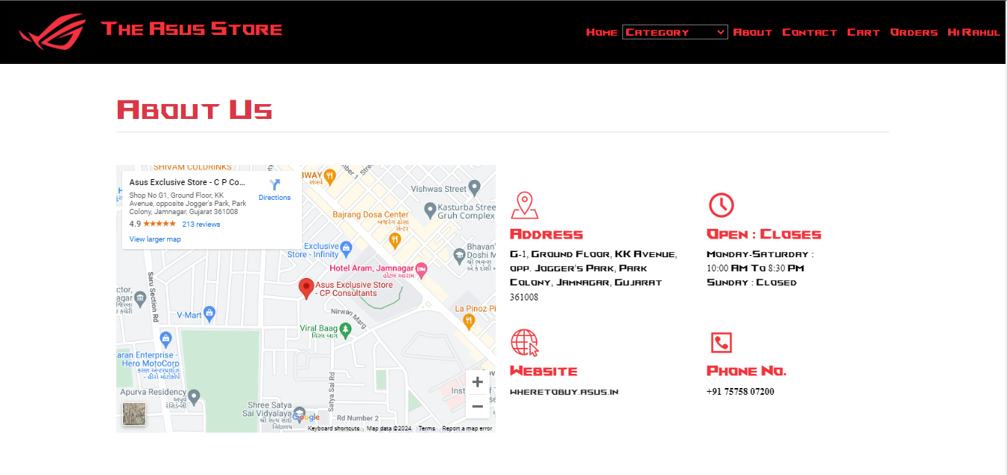

6.12 This Page Shows the Details of the Company

* **Contact Us Page:**

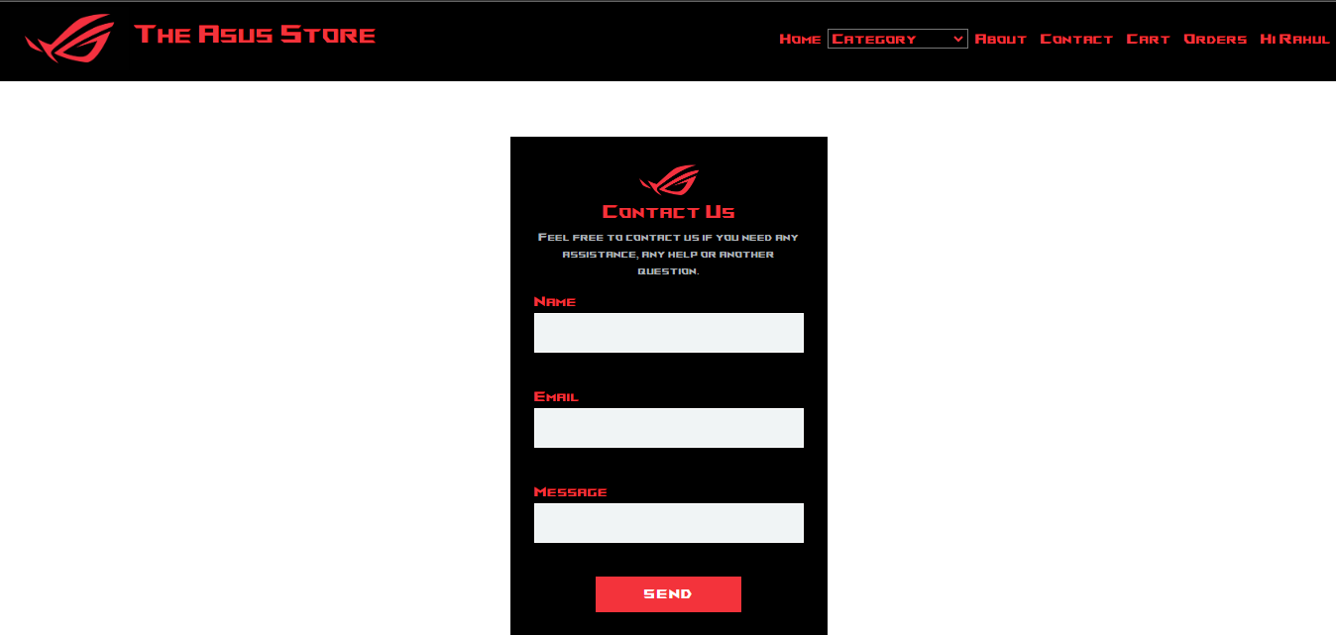

6.13 This Page Shows the Contact Form

* **Admin Side**
* **Login Page**



6.1.1 This Page Allows Admin to log in

* **Dashboard View**

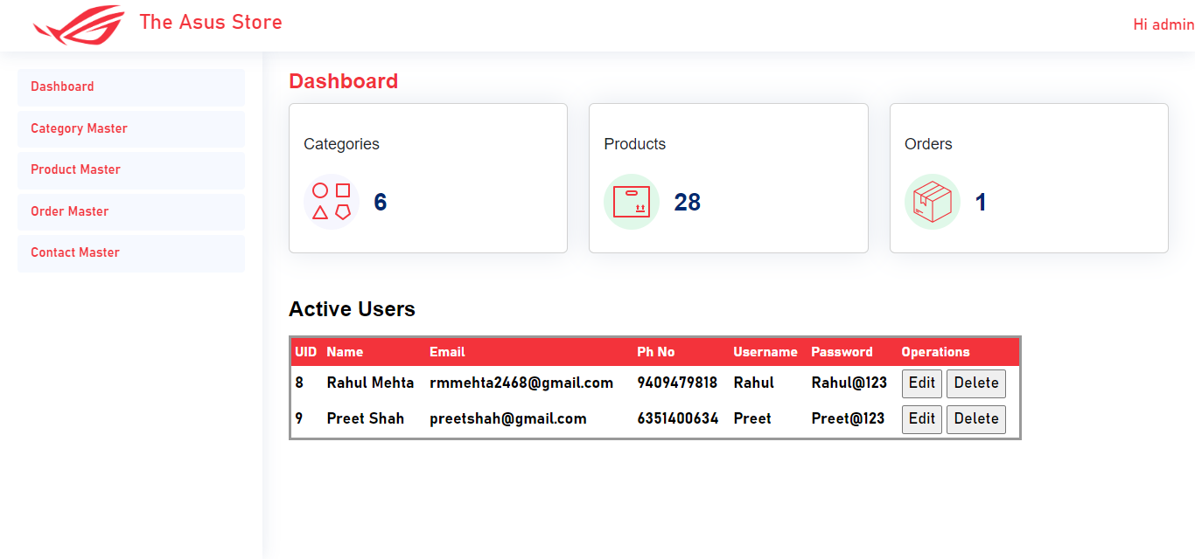

6.1.2 This Page Shows the Dashboard View

* **Category Master Page**

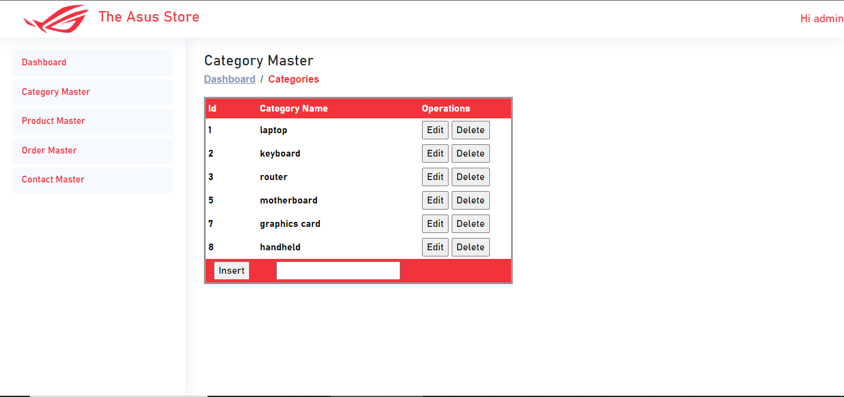

6.1.3 This Page Allows Admin to Manage Categories

* **Product Master Page**

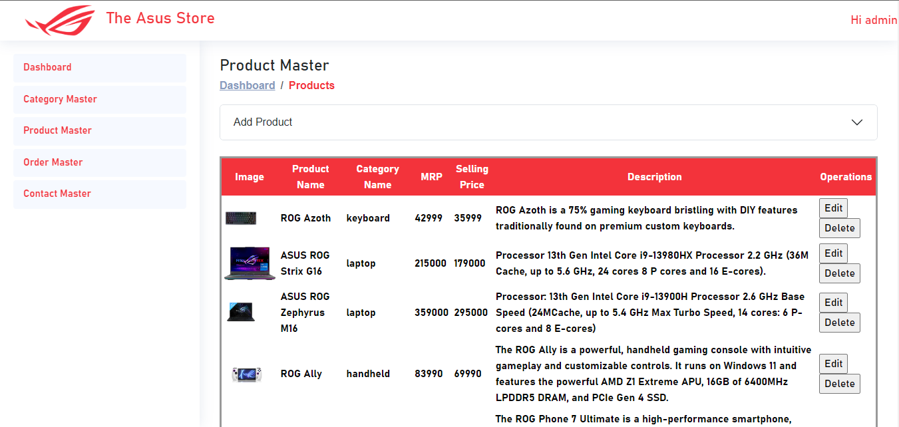

6.1.4 This Page Allows Admin to Manage Products

* **Order Master Page**

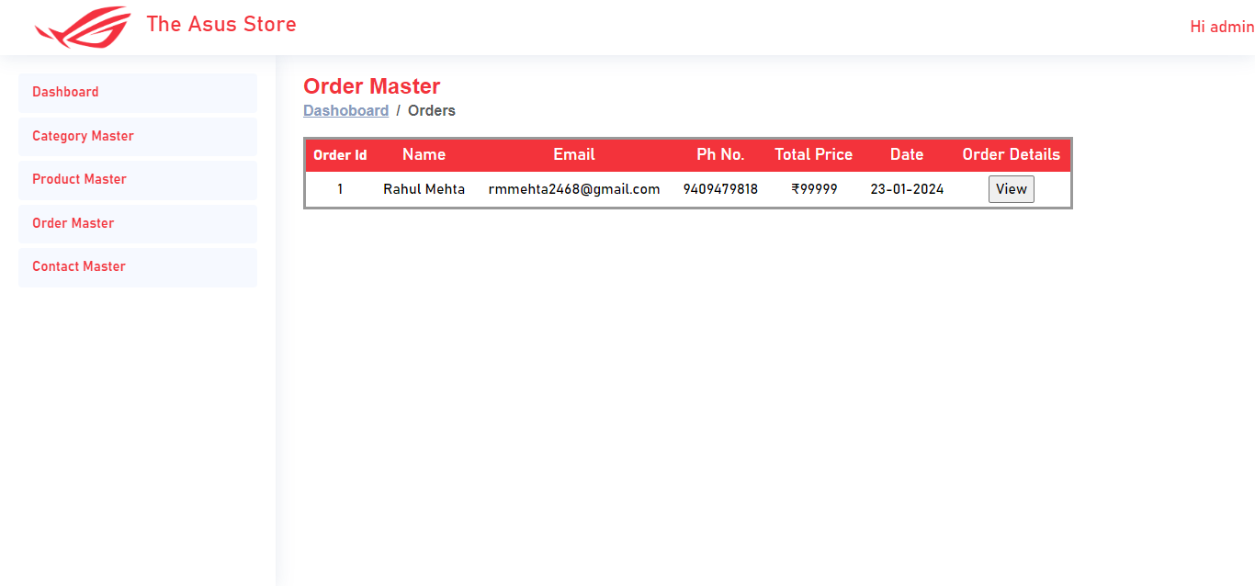

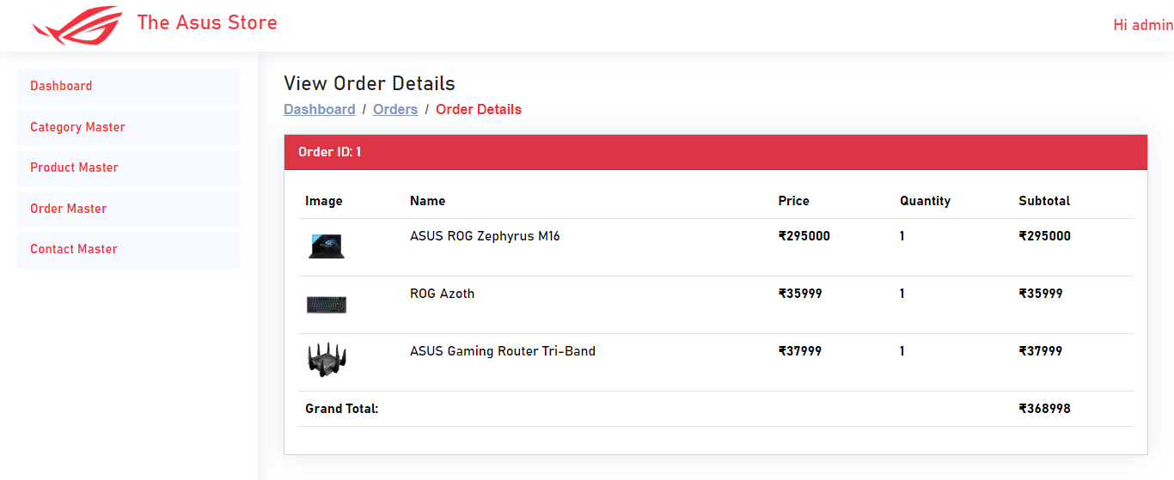

6.1.5 This Page Allows Admin to View All Orders

1. **LIMITATIONS AND FUTURE ENHANCEMENT**

* **Limitations:-**
* The limitation in the Asus Store is that the client can’t cancel the order once placed.
* The customer can doesn’t have the real-time status of his/her order placed.
* After placing an order the customer isn’t provided with a real-time tracking link of that order.
* **Future Enhancement:-**
* In the future, overall website design will be improved.
* A solution for updating the profile of the customer would be found.
* User management rights would be provided to the admin.
* Real-time delivery status will be shown to the customer once the order is placed.
* All other limitations would be removed.

1. **CONCLUSION**

The project report entitled Asus Store has been completed successfully. This website has been developed with much care that is free of errors and at the same time it is efficient and less time-consuming. I have tried my level best to make this website as dynamic as possible. Also, provision is provided for future development of the website. This website will be approved and implemented soon.

1. **REFERENCES AND BIBLIOGRAPHY**

All the references listed below were used to develop and design this website and were also used for documentation. I am thankful to each and every person who helped me and supported for this project's completion.

* Books:-
* ASP.NET Programming by Prof. Nilesh Advani
* ASP.NET by Bharat Prakashan
* Websites:-
  + [www.stackoverflow.com](http://www.stackoverflow.com)
  + [www.javatpoint.com](http://www.javatpoint.com)
  + [www.w3schools.com](http://www.w3schools.com)
  + [www.bootstrap.com](http://www.bootstrap.com)
  + www.chat.openai.com